Образец
(примерная структура)
контрольного теста по английскому языку 6 класс
Критерии оценки:
«5» - 48 – 50 баллов
«4»- 47 – 40 баллов
«3»- 39 – 30 баллов
«2» -29 - 0 баллов

Task 1. Complete the chart (15 points)
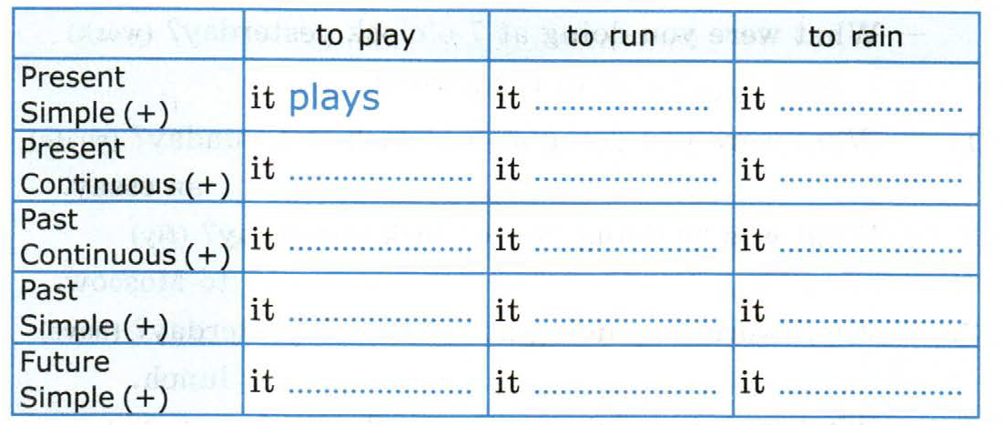
Task 2. Use the verb in the necessary grammar forms and complete the text (15 points)
- I (not to dance_______________________________) for ages.
- I never (to be_________________________________) to the Bahamas.
- When you (to see_______________________________) the “Swan Lake”?
- At this time yesterday I (to talk____________________________________) to my friend.
- I (not to eat____________________________________) ice cream since summer.
- He just (to spend_____________________________) all his money.
- He (to come__________________________________) home late yesterday.
- She (to translate________________________________) the whole text by 11 o’clock.
- Last year we (to work__________________________________) very much.
- I (to see____________________________) an interesting TV program this week.
- It (be) a wonderful day.
- When I ( come_____________) home from school, I (have_________) dinner and ( begin_____________) doing my homework.
- I want to tell you what ( happen_______________) to me yesterday afternoon
- He already (to write____________________________) an essay.
- We (to walk_______________________) in the park, dad ( to come____________) home.
Task3. Write the same in English. (5 points)
1.Наша задача – защищать окружающую среду_____________________
2. Если по прогнозу не будет заморозков, мы пойдем на пикник.___________
3.Мы все хотим жить в хорошей окружающей среде._____________________________
4.Прогноз погоды говорит о дожде._______________________________
5. Мы все должны защищать окружающую среду_______________
.
Task4. Change the sentences to use passive structures and write them down(10points)
- He will introduce me to his friends._________________________________________
- You must take the box to the station.________________________________________
- You can cross the river on a raft._____________________________________________
- The workers can finish the building of the house very soon.___________________________________________________________________
- We must send these letters at once.__________________________________________
- You can do the work in three days.___________________________________________
- They sell milk in this shop. _________________________________________________
- They speak English in France and Canada.______________________________________
- People invented surfing a long time ago._______________________________________
- People make jams from different fruit.________________________________________
Task5. Choose the right answer. (5 points)
1.Туманный:
А) foggy B) cloudy C) frosty
2.Ниже нуля:
A) above zero B) one zero C) below zero
3. Жаркая погода:
A) the weather is sunny B) the weather is hot C) the weather is rainy
4. Морозит:
A) it freezes B) it melts C) it snows
5. Дождь:
A) a snow B) a rain C) a storm

